Nama : Pasha Muhammad Nashwan
NRP : 152023155

PPT 9 Exception Handling

TryCatchExample3
public class TryCatchExample3 {
public static void main(String[] args) {
try
{
int data=50/0;
System.out.println("rest of the code");
}
catch(ArithmeticException e)
{
System.out.println(e);
}
}
}

Output :
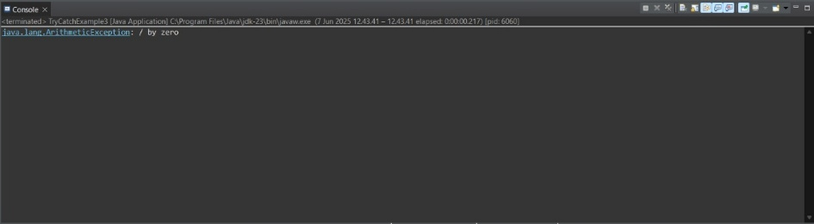

TryCatchExample4
public class TryCatchExample4 {
public static void main(String[] args) {
try
{
int data=50/0;
}
catch(Exception e)
{
System.out.println(e);
}
System.out.println("rest of the code");
}
}

Output :
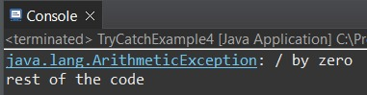

TryCatchExample5
public class TryCatchExample5 {
public static void main(String[] args) {
try
{
int data=50/0;
}
catch(Exception e)
{
System.out.println("Can't divided by zero");
}
}
}

Output :
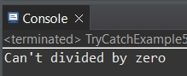

TryCatchExample6
public class TryCatchExample6 {
public static void main(String[] args) {
int i=50;
int j=0;
int data;

try
{
data=i/j; //may throw exception
}
// handling the exception
catch(Exception e)
{
// resolving the exception in catch block
System.out.println(i/(j+2));
}
}
}

Output :
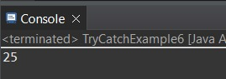

TryCatchExample7
public class TryCatchExample7 {
public static void main(String[] args) {
try
{
int data1=50/0; //may throw exception
}
// handling the exception
catch(Exception e)
{
// generating the exception in catch block
int data2=50/0; //may throw exception
}
System.out.println("rest of the code");
}
}

Output :
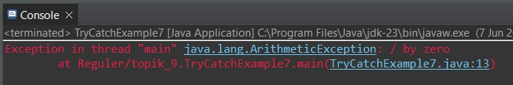

TryCatchExample8
public class TryCatchExample8 {
public static void main(String[] args) {
try
{
int data=50/0; //may throw exception
}
// try to handle the ArithmeticException using ArrayIndexOutOfBoundsException
catch(ArrayIndexOutOfBoundsException e)
{
System.out.println(e);
}
System.out.println("rest of the code");
}
}

Output :
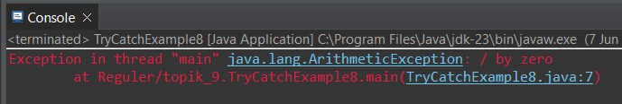

TryCatchExample9
public class TryCatchExample9 {
public static void main(String[] args) {
try
{
int arr[]= {1,3,5,7};
System.out.println(arr[10]); //may throw exception
}
// handling the array exception
catch(ArrayIndexOutOfBoundsException e)
{
System.out.println(e);
}
System.out.println("rest of the code");
}
}

Output :
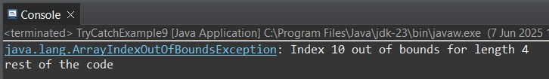

TryCatchExample10
import java.io.FileNotFoundException;
import java.io.PrintWriter;

public class TryCatchExample10 {
public static void main(String[] args) {
PrintWriter pw;
try {
pw = new PrintWriter("jtp.txt"); //may throw exception
pw.println("saved");
}
// providing the checked exception handler
catch (FileNotFoundException e) {
System.out.println(e);
}
System.out.println("File saved successfully");
}
}

Output :
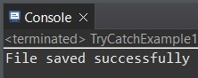
PPT 10 JDBC

Tugas P 10
- Unduh JDBC
- Buat database sederhana, cukup database nim dan nama mahasiswa.
- Buatkan program Java yang bisa koneksi ke database, kemudian bisa melakukan insert data, dan melihat data.

Mahasiswa_db
-- Buat database
CREATE DATABASE mahasiswa_db;

-- Gunakan database
USE mahasiswa_db;

-- Buat tabel mahasiswa
CREATE TABLE mahasiswa (
nim VARCHAR(20) PRIMARY KEY,
nama VARCHAR(100) NOT NULL
);

-- Insert sample data (opsional)
INSERT INTO mahasiswa (nim, nama) VALUES
('2024001', 'ahmad rizki'),
('2024002', 'siti nurhaliza');

JDBC
<dependency>
<groupId>mysql</groupId>
<artifactId>mysql-connector-java</artifactId>
<version>8.0.33</version>
</dependency>

DatabaseConnection.java
import java.sql.*;

public class DatabaseConnection {
// Konfigurasi database
private static final String URL = "jdbc:mysql://localhost:3306/mahasiswa_db";
private static final String USERNAME = "root"; // Ganti dengan username MySQL Anda
private static final String PASSWORD = ""; // Ganti dengan password MySQL Anda

// Method untuk mendapatkan koneksi database
public static Connection getConnection() throws SQLException {
try {
Class.forName("com.mysql.cj.jdbc.Driver");
return DriverManager.getConnection(URL, USERNAME, PASSWORD);
} catch (ClassNotFoundException e) {
throw new SQLException("Driver MySQL tidak ditemukan: " + e.getMessage());
}
}
}

mahasiswaDao.java
import java.sql.*;
import java.util.ArrayList;
import java.util.List;

public class MahasiswaDAO {

// Method untuk insert data mahasiswa
public boolean insertMahasiswa(String nim, String nama) {
String query = "INSERT INTO mahasiswa (nim, nama) VALUES (?, ?)";

try (Connection conn = DatabaseConnection.getConnection();
PreparedStatement pstmt = conn.prepareStatement(query)) {

pstmt.setString(1, nim);
pstmt.setString(2, nama);

int rowsAffected = pstmt.executeUpdate();
return rowsAffected > 0;

} catch (SQLException e) {
System.err.println("Error saat insert data: " + e.getMessage());
return false;
}
}

// Method untuk melihat semua data mahasiswa
public List<String[]> getAllMahasiswa() {
List<String[]> mahasiswaList = new ArrayList<>();
String query = "SELECT nim, nama FROM mahasiswa ORDER BY nim";

try (Connection conn = DatabaseConnection.getConnection();
Statement stmt = conn.createStatement();
ResultSet rs = stmt.executeQuery(query)) {

while (rs.next()) {
String[] mahasiswa = {
rs.getString("nim"),
rs.getString("nama")
};
mahasiswaList.add(mahasiswa);
}

} catch (SQLException e) {
System.err.println("Error saat mengambil data: " + e.getMessage());
}

return mahasiswaList;
}

// Method untuk mencari mahasiswa berdasarkan NIM
public String[] getMahasiswaByNim(String nim) {
String query = "SELECT nim, nama FROM mahasiswa WHERE nim = ?";

try (Connection conn = DatabaseConnection.getConnection();
PreparedStatement pstmt = conn.prepareStatement(query)) {

pstmt.setString(1, nim);
ResultSet rs = pstmt.executeQuery();

if (rs.next()) {
return new String[]{
rs.getString("nim"),
rs.getString("nama")
};
}

} catch (SQLException e) {
System.err.println("Error saat mencari data: " + e.getMessage());
}

return null;
}
}

Main.java
import java.util.List;
import java.util.Scanner;

public class Main {
private static MahasiswaDAO mahasiswaDAO = new MahasiswaDAO();
private static Scanner scanner = new Scanner(System.in);

public static void main(String[] args) {
System.out.println("=== SISTEM MANAJEMEN DATA MAHASISWA ===");

while (true) {
tampilkanMenu();
int pilihan = scanner.nextInt();
scanner.nextLine(); // Consume newline

switch (pilihan) {
case 1:
insertDataMahasiswa();
break;
case 2:
tampilkanSemuaData();
break;
case 3:
cariMahasiswa();
break;
case 4:
System.out.println("Terima kasih!");
System.exit(0);
break;
default:
System.out.println("Pilihan tidak valid!");
}

System.out.println("\nTekan Enter untuk melanjutkan...");
scanner.nextLine();
}
}

private static void tampilkanMenu() {
System.out.println("\n" + "=".repeat(40));
System.out.println("MENU UTAMA");
System.out.println("=".repeat(40));
System.out.println("1. Tambah Data Mahasiswa");
System.out.println("2. Tampilkan Semua Data");
System.out.println("3. Cari Mahasiswa");
System.out.println("4. Keluar");
System.out.print("Pilih menu (1-4): ");
}

private static void insertDataMahasiswa() {
System.out.println("\n--- TAMBAH DATA MAHASISWA ---");
System.out.print("Masukkan NIM: ");
String nim = scanner.nextLine();

System.out.print("Masukkan Nama: ");
String nama = scanner.nextLine();

if (mahasiswaDAO.insertMahasiswa(nim, nama)) {
System.out.println("✓ Data mahasiswa berhasil ditambahkan!");
} else {
System.out.println("✗ Gagal menambahkan data mahasiswa!");
}
}

private static void tampilkanSemuaData() {
System.out.println("\n--- DAFTAR SEMUA MAHASISWA ---");
List<String[]> mahasiswaList = mahasiswaDAO.getAllMahasiswa();

if (mahasiswaList.isEmpty()) {
System.out.println("Tidak ada data mahasiswa.");
return;
}

System.out.println("-".repeat(50));
System.out.printf("%-15s | %-30s%n", "NIM", "NAMA");
System.out.println("-".repeat(50));

for (String[] mahasiswa : mahasiswaList) {
System.out.printf("%-15s | %-30s%n", mahasiswa[0], mahasiswa[1]);
}

System.out.println("-".repeat(50));
System.out.println("Total: " + mahasiswaList.size() + " mahasiswa");
}

private static void cariMahasiswa() {
System.out.println("\n--- CARI MAHASISWA ---");
System.out.print("Masukkan NIM: ");
String nim = scanner.nextLine();

String[] mahasiswa = mahasiswaDAO.getMahasiswaByNim(nim);

if (mahasiswa != null) {
System.out.println("\n✓ Data ditemukan:");
System.out.println("NIM : " + mahasiswa[0]);
System.out.println("Nama : " + mahasiswa[1]);
} else {
System.out.println("✗ Data mahasiswa dengan NIM '" + nim + "' tidak ditemukan!");
}
}
}

Output :
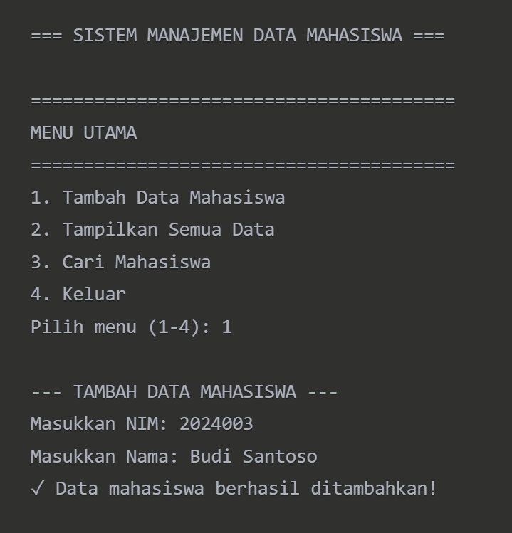
PPT 11 GUI

- Buatkan program kalkulator dengan Java (pakai GUI):
  - Ada kali, bagi, tambah, kurang
  - Ada akar kuadrat
- Buatkan aplikas i databas e (CRUD) de ngan GUI

1. Kalkulator.java
package topik_10;

import javax.swing.*;
import java.awt.*;
import java.awt.event.*;

public class kalkulator extends JFrame implements ActionListener {
private JTextField display;
private double angkaPertama, angkaKedua, hasil;
private String operator;

public kalkulator() {
setTitle("Kalkulator");
setSize(300, 400);
setDefaultCloseOperation(JFrame.EXIT_ON_CLOSE);
setLayout(new BorderLayout());

display = new JTextField();
display.setFont(new Font("Arial", Font.PLAIN, 24));
display.setHorizontalAlignment(JTextField.RIGHT);
display.setEditable(false);
add(display, BorderLayout.NORTH);

JPanel buttonPanel = new JPanel();
buttonPanel.setLayout(new GridLayout(5, 4, 5, 5));

String[] buttons = {
"7", "8", "9", "/",
"4", "5", "6", "*",
"1", "2", "3", "-",
"0", ".", "=", "+",
"√", "C"
};

for (String text : buttons) {
JButton button = new JButton(text);
button.setFont(new Font("Arial", Font.PLAIN, 18));
button.addActionListener(this);
buttonPanel.add(button);
}

add(buttonPanel, BorderLayout.CENTER);
}

@Override
public void actionPerformed(ActionEvent e) {
String command = e.getActionCommand();

if (command.matches("[0-9]")) {
display.setText(display.getText() + command);
} else if (command.equals(".")) {
if (!display.getText().contains(".")) {
display.setText(display.getText() + ".");
}
} else if (command.equals("C")) {
display.setText("");
angkaPertama = angkaKedua = hasil = 0;
operator = null;
} else if (command.matches("[+\\-*/]")) {
angkaPertama = Double.parseDouble(display.getText());
operator = command;
display.setText("");
} else if (command.equals("=")) {
if (operator != null) {
angkaKedua = Double.parseDouble(display.getText());
switch (operator) {
case "+":
hasil = angkaPertama + angkaKedua;
break;
case "-":
hasil = angkaPertama - angkaKedua;
break;
case "*":
hasil = angkaPertama * angkaKedua;
break;
case "/":
hasil = angkaPertama / angkaKedua;
break;
}
display.setText(String.valueOf(hasil));
operator = null;
}
} else if (command.equals("√")) {
double value = Double.parseDouble(display.getText());
hasil = Math.sqrt(value);
display.setText(String.valueOf(hasil));
}
}

public static void main(String[] args) {
SwingUtilities.invokeLater(() -> {
kalkulator kalkulator = new kalkulator();
kalkulator.setVisible(true);
});
}

}

Output :
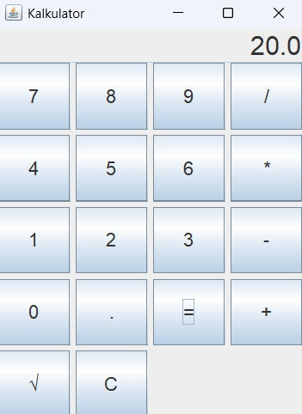

2. DatabaseCRUD.java
package topik_10;

import javax.swing.*;
import java.awt.*;
import java.awt.event.*;
import java.sql.*;
import java.util.ArrayList;
import java.util.List;

public class DatabaseCRUD extends JFrame {
private Connection connection;
private List<Mahasiswa> dataMahasiswa = new ArrayList<>();
private JTable table;
private MahasiswaTableModel tableModel;

public DatabaseCRUD() {
setTitle("Aplikasi Database CRUD dengan MySQL");
setSize(600, 400);
setDefaultCloseOperation(JFrame.EXIT_ON_CLOSE);

koneksiDatabase();

JPanel mainPanel = new JPanel(new BorderLayout());

JPanel formPanel = new JPanel(new GridLayout(4, 2, 5, 5));

JLabel lblNim = new JLabel("NIM:");
JTextField txtNim = new JTextField();
JLabel lblNama = new JLabel("Nama:");
JTextField txtNama = new JTextField();
JLabel lblJurusan = new JLabel("Jurusan:");
JTextField txtJurusan = new JTextField();

formPanel.add(lblNim);
formPanel.add(txtNim);
formPanel.add(lblNama);
formPanel.add(txtNama);
formPanel.add(lblJurusan);
formPanel.add(txtJurusan);

// Panel tombol
JPanel buttonPanel = new JPanel(new FlowLayout());
JButton btnTambah = new JButton("Tambah");
JButton btnUpdate = new JButton("Update");
JButton btnHapus = new JButton("Hapus");
JButton btnRefresh = new JButton("Refresh");

buttonPanel.add(btnTambah);
buttonPanel.add(btnUpdate);
buttonPanel.add(btnHapus);
buttonPanel.add(btnRefresh);

tableModel = new MahasiswaTableModel(dataMahasiswa);
table = new JTable(tableModel);
JScrollPane scrollPane = new JScrollPane(table);

mainPanel.add(formPanel, BorderLayout.NORTH);
mainPanel.add(buttonPanel, BorderLayout.CENTER);
mainPanel.add(scrollPane, BorderLayout.SOUTH);

add(mainPanel);

refreshData();

btnTambah.addActionListener(e -> {
try {
String nim = txtNim.getText();
String nama = txtNama.getText();
String jurusan = txtJurusan.getText();

if (nim.isEmpty() || nama.isEmpty() || jurusan.isEmpty()) {
JOptionPane.showMessageDialog(this, "Semua field harus diisi!");
return;
}

tambahData(new Mahasiswa(nim, nama, jurusan));
refreshData();
clearForm(txtNim, txtNama, txtJurusan);
} catch (Exception ex) {
JOptionPane.showMessageDialog(this, "Error: " + ex.getMessage());
}
});

btnUpdate.addActionListener(e -> {
try {
int selectedRow = table.getSelectedRow();
if (selectedRow == -1) {
JOptionPane.showMessageDialog(this, "Pilih data yang akan diupdate!");
return;
}

String nim = txtNim.getText();
String nama = txtNama.getText();
String jurusan = txtJurusan.getText();

if (nim.isEmpty() || nama.isEmpty() || jurusan.isEmpty()) {
JOptionPane.showMessageDialog(this, "Semua field harus diisi!");
return;
}

Mahasiswa mhs = dataMahasiswa.get(selectedRow);
mhs.setNim(nim);
mhs.setNama(nama);
mhs.setJurusan(jurusan);

updateData(mhs);
refreshData();
clearForm(txtNim, txtNama, txtJurusan);
} catch (Exception ex) {
JOptionPane.showMessageDialog(this, "Error: " + ex.getMessage());
}
});

btnHapus.addActionListener(e -> {
try {
int selectedRow = table.getSelectedRow();
if (selectedRow == -1) {
JOptionPane.showMessageDialog(this, "Pilih data yang akan dihapus!");
return;
}

Mahasiswa mhs = dataMahasiswa.get(selectedRow);
hapusData(mhs.getNim());
refreshData();
clearForm(txtNim, txtNama, txtJurusan);
} catch (Exception ex) {
JOptionPane.showMessageDialog(this, "Error: " + ex.getMessage());
}
});

btnRefresh.addActionListener(e -> {
refreshData();
clearForm(txtNim, txtNama, txtJurusan);
});

table.getSelectionModel().addListSelectionListener(e -> {
if (!e.getValueIsAdjusting()) {
int selectedRow = table.getSelectedRow();
if (selectedRow >= 0) {
Mahasiswa mhs = dataMahasiswa.get(selectedRow);
txtNim.setText(mhs.getNim());
txtNama.setText(mhs.getNama());
txtJurusan.setText(mhs.getJurusan());
}
}
});
}

private void koneksiDatabase() {
try {
Class.forName("com.mysql.cj.jdbc.Driver");

String url = "jdbc:mysql://localhost:3306/db_mahasiswa";
String username = "root";
String password = "";

connection = DriverManager.getConnection(url, username, password);

Statement stmt = connection.createStatement();
stmt.execute("CREATE TABLE IF NOT EXISTS mahasiswa (" +
"nim VARCHAR(20) PRIMARY KEY, " +
"nama VARCHAR(100), " +
"jurusan VARCHAR(50))");
} catch (Exception e) {
JOptionPane.showMessageDialog(this, "Error koneksi database: " + e.getMessage());
System.exit(1);
}
}

private void tambahData(Mahasiswa mhs) throws SQLException {
String sql = "INSERT INTO mahasiswa (nim, nama, jurusan) VALUES (?, ?, ?)";
PreparedStatement pstmt = connection.prepareStatement(sql);
pstmt.setString(1, mhs.getNim());
pstmt.setString(2, mhs.getNama());
pstmt.setString(3, mhs.getJurusan());
pstmt.executeUpdate();
}

private void updateData(Mahasiswa mhs) throws SQLException {
String sql = "UPDATE mahasiswa SET nama = ?, jurusan = ? WHERE nim = ?";
PreparedStatement pstmt = connection.prepareStatement(sql);
pstmt.setString(1, mhs.getNama());
pstmt.setString(2, mhs.getJurusan());
pstmt.setString(3, mhs.getNim());
pstmt.executeUpdate();
}

private void hapusData(String nim) throws SQLException {
String sql = "DELETE FROM mahasiswa WHERE nim = ?";
PreparedStatement pstmt = connection.prepareStatement(sql);
pstmt.setString(1, nim);
pstmt.executeUpdate();
}

private void refreshData() {
try {
dataMahasiswa.clear();
Statement stmt = connection.createStatement();
ResultSet rs = stmt.executeQuery("SELECT * FROM mahasiswa");

while (rs.next()) {
String nim = rs.getString("nim");
String nama = rs.getString("nama");
String jurusan = rs.getString("jurusan");
dataMahasiswa.add(new Mahasiswa(nim, nama, jurusan));
}

tableModel.fireTableDataChanged();
} catch (SQLException e) {
JOptionPane.showMessageDialog(this, "Error memuat data: " + e.getMessage());
}
}

private void clearForm(JTextField... fields) {
for (JTextField field : fields) {
field.setText("");
}
}

public static void main(String[] args) {
SwingUtilities.invokeLater(() -> {
DatabaseCRUD app = new DatabaseCRUD();
app.setVisible(true);
});
}
}

class Mahasiswa {
private String nim;
private String nama;
private String jurusan;

public Mahasiswa(String nim, String nama, String jurusan) {
this.nim = nim;
this.nama = nama;
this.jurusan = jurusan;
}

public String getNim() { return nim; }
public void setNim(String nim) { this.nim = nim; }
public String getNama() { return nama; }
public void setNama(String nama) { this.nama = nama; }
public String getJurusan() { return jurusan; }
public void setJurusan(String jurusan) { this.jurusan = jurusan; }
}

class MahasiswaTableModel extends javax.swing.table.AbstractTableModel {
private List<Mahasiswa> data;
private String[] columnNames = {"NIM", "Nama", "Jurusan"};

public MahasiswaTableModel(List<Mahasiswa> data) {
this.data = data;
}

@Override
public int getRowCount() { return data.size(); }

@Override
public int getColumnCount() { return columnNames.length; }

@Override
public String getColumnName(int col) { return columnNames[col]; }

@Override
public Object getValueAt(int row, int col) {
Mahasiswa mhs = data.get(row);
switch (col) {
case 0: return mhs.getNim();
case 1: return mhs.getNama();
case 2: return mhs.getJurusan();
default: return null;
}
}
}

Ouput :
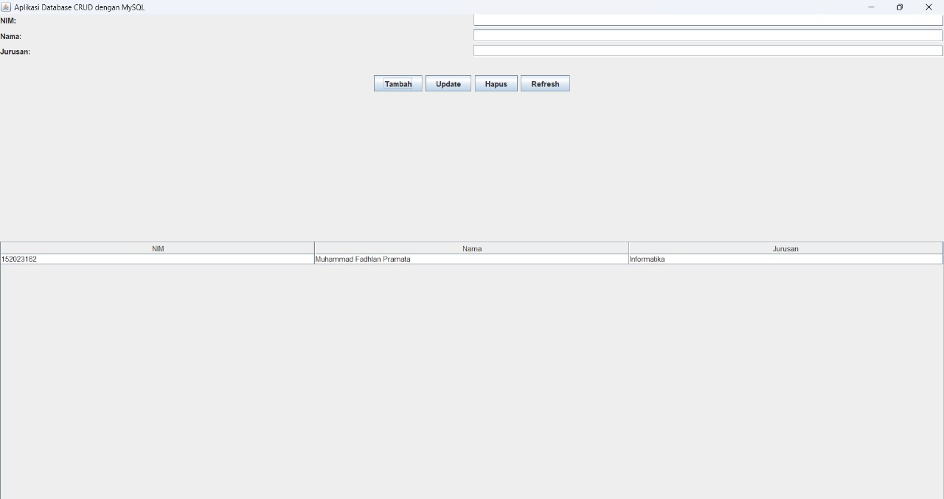

PPT 12 MVC

Tugas buatkan contoh aplikasi Java dengan pola MVC

View
//MahasiswaView.java
package view;

import java.util.Scanner;

import controller.MahasiswaController;

public class MahasiswaView {
private Scanner scanner;

public MahasiswaView() {
scanner = new Scanner(System.in);
}

public void tampilkanMenu() {
System.out.println("\n=== Aplikasi Manajemen Mahasiswa ===");
System.out.println("1. Tambah Mahasiswa");
System.out.println("2. Tampilkan Semua Mahasiswa");
System.out.println("3. Keluar");
System.out.print("Pilih menu: ");
}

public String[] inputDataMahasiswa() {
System.out.println("\nMasukkan Data Mahasiswa:");
System.out.print("NIM: ");
String nim = scanner.nextLine();
System.out.print("Nama: ");
String nama = scanner.nextLine();
System.out.print("Jurusan: ");
String jurusan = scanner.nextLine();

return new String[]{nim, nama, jurusan};
}

public void tampilkanMahasiswa(String nim, String nama, String jurusan) {
System.out.println("\nData Mahasiswa:");
System.out.println("NIM: " + nim);
System.out.println("Nama: " + nama);
System.out.println("Jurusan: " + jurusan);
}

public void tampilkanPesan(String pesan) {
System.out.println(pesan);
}

public int getInputMenu() {
try {
return Integer.parseInt(scanner.nextLine());
} catch (NumberFormatException e) {
return -1;
}
}

public static void main(String[] args) {
MahasiswaView view = new MahasiswaView();
MahasiswaController controller = new MahasiswaController(view);

while (true) {
view.tampilkanMenu();
int pilihan = view.getInputMenu();
controller.prosesInputMenu(pilihan);
}
}
}

Model
//Mahasiswa.java
package model;

public class Mahasiswa {
private String nim;
private String nama;
private String jurusan;

public Mahasiswa(String nim, String nama, String jurusan) {
this.nim = nim;
this.nama = nama;
this.jurusan = jurusan;
}

// Getter dan Setter
public String getNim() {
return nim;
}

public void setNim(String nim) {
this.nim = nim;
}

public String getNama() {
return nama;
}

public void setNama(String nama) {
this.nama = nama;
}

public String getJurusan() {
return jurusan;
}

public void setJurusan(String jurusan) {
this.jurusan = jurusan;
}
}

Controller
//MahasiswaController.java
package controller;

import java.util.ArrayList;
import java.util.List;
import model.Mahasiswa;
import view.MahasiswaView;

public class MahasiswaController {
private List<Mahasiswa> daftarMahasiswa;
private MahasiswaView view;

public MahasiswaController(MahasiswaView view) {
this.daftarMahasiswa = new ArrayList<>();
this.view = view;
}

public void tambahMahasiswa(String nim, String nama, String jurusan) {
Mahasiswa mhs = new Mahasiswa(nim, nama, jurusan);
daftarMahasiswa.add(mhs);
view.tampilkanPesan("Mahasiswa berhasil ditambahkan!");
}

public void tampilkanSemuaMahasiswa() {
if (daftarMahasiswa.isEmpty()) {
view.tampilkanPesan("Belum ada data mahasiswa.");
} else {
for (Mahasiswa mhs : daftarMahasiswa) {
view.tampilkanMahasiswa(mhs.getNim(), mhs.getNama(), mhs.getJurusan());
}
}
}

public void prosesInputMenu(int pilihan) {
switch (pilihan) {
case 1:
String[] data = view.inputDataMahasiswa();
tambahMahasiswa(data[0], data[1], data[2]);
break;
case 2:
tampilkanSemuaMahasiswa();
break;
case 3:
view.tampilkanPesan("Terima kasih telah menggunakan aplikasi.");
System.exit(0);
break;
default:
view.tampilkanPesan("Pilihan tidak valid. Silakan coba lagi.");
}
}
}

Output :
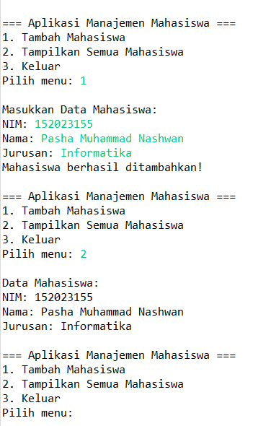

PPT 13 Spring MVC

- Tugas: Coba ikuti tutorial yang ditunjukkan di atas, atau yang lain yang menjelaskan pembauatan aplikasi dengan Spring MVC.
- Coba juga dengan STS: Spring Tools Suite

LoginController.java
package com.example.pertemuan6.controller;

import org.springframework.beans.factory.annotation.Autowired;
import org.springframework.stereotype.Controller;
import org.springframework.ui.Model;
import org.springframework.web.bind.annotation.*;

import com.example.pertemuan6.model.User;
import com.example.pertemuan6.repository.UserRepository;

@Controller
public class LoginController {

@Autowired
private UserRepository userRepo;

@GetMapping("/")
public String loginForm(Model model) {
model.addAttribute("user", new User());
return "login";
}

@PostMapping("/login")
public String login(@ModelAttribute User user, Model model) {
User u = userRepo.findByUsernameAndPassword(user.getUsername(), user.getPassword());
if (u != null) {
return "redirect:/mahasiswa";
}
model.addAttribute("error", "Username atau Password salah");
return "login";
}

@GetMapping("/register")
public String registerForm(Model model) {
model.addAttribute("user", new User());
return "register";
}

@PostMapping("/register")
public String register(@ModelAttribute User user) {
userRepo.save(user);
return "redirect:/";
}
}

MahasiswaController.java
package com.example.pertemuan6.controller;

import org.springframework.beans.factory.annotation.Autowired;
import org.springframework.stereotype.Controller;
import org.springframework.ui.Model;
import org.springframework.web.bind.annotation.GetMapping;
import org.springframework.web.bind.annotation.ModelAttribute;
import org.springframework.web.bind.annotation.PathVariable;
import org.springframework.web.bind.annotation.PostMapping;

import com.example.pertemuan6.model.Mahasiswa;
import com.example.pertemuan6.repository.MahasiswaRepository;

@Controller
public class MahasiswaController {

@Autowired
private MahasiswaRepository repo;

@GetMapping("/mahasiswa")
public String index(Model model) {
model.addAttribute("listMahasiswa", repo.findAll());
return "index";
}

@GetMapping("/tambah")
public String tambahForm(Model model) {
model.addAttribute("mahasiswa", new Mahasiswa());
return "add";
}

@PostMapping("/simpan")
public String simpan(@ModelAttribute Mahasiswa mahasiswa) {
repo.save(mahasiswa);
return "redirect:/";
}

@GetMapping("/edit/{id}")
public String editForm(@PathVariable Long id, Model model) {
model.addAttribute("mahasiswa", repo.findById(id).orElse(null));
return "edit";
}

@PostMapping("/update")
public String update(@ModelAttribute Mahasiswa mahasiswa) {
repo.save(mahasiswa);
return "redirect:/";
}

@GetMapping("/hapus/{id}")
public String hapus(@PathVariable Long id) {
repo.deleteById(id);
return "redirect:/";
}

}

Mahasiswa.java
package com.example.pertemuan6.model;

import jakarta.persistence.*;

@Entity
public class Mahasiswa {
@Id
@GeneratedValue(strategy = GenerationType.IDENTITY)
private Long id;

private String nama;
private String nim;
private String jurusan;

public Mahasiswa() {
//
}

public Mahasiswa(String nama, String nim, String jurusan) {
this.nama = nama;
this.nim = nim;
this.jurusan = jurusan;
}

public Long getId() {
return id;
}

public void setId(Long id) {
this.id = id;
}

public String getNama() {
return nama;
}

public void setNama(String nama) {
this.nama = nama;
}

public String getNim() {
return nim;
}

public void setNim(String nim) {
this.nim = nim;
}

public String getJurusan() {
return jurusan;
}

public void setJurusan(String jurusan) {
this.jurusan = jurusan;
}
}

User.java
package com.example.pertemuan6.model;

import jakarta.persistence.*;

@Entity
public class User {
@Id
@GeneratedValue(strategy = GenerationType.IDENTITY)
private Long id;

private String username;
private String password;

public User() {}

public User(String username, String password) {
this.username = username;
this.password = password;
}

// getter setter

public Long getId() {
return id;
}

public void setId(Long id) {
this.id = id;
}

public String getUsername() {
return username;
}

public void setUsername(String username) {
this.username = username;
}

public String getPassword() {
return password;
}

public void setPassword(String password) {
this.password = password;
}
}

MahasiswaRepository.java
package com.example.pertemuan6.repository;

import org.springframework.data.jpa.repository.JpaRepository;

import com.example.pertemuan6.model.Mahasiswa;

public interface MahasiswaRepository extends JpaRepository<Mahasiswa, Long> {

}

UserRepository.java
package com.example.pertemuan6.repository;

import org.springframework.data.jpa.repository.JpaRepository;
import com.example.pertemuan6.model.User;

public interface UserRepository extends JpaRepository<User, Long> {
User findByUsernameAndPassword(String username, String password);
User findByUsername(String username);
}

Add.html
<!DOCTYPE html>
<html lang="en" xmlns:th="http://www.thymeleaf.org">

<head>
<meta charset="UTF-8" />
<meta name="viewport" content="width=device-width, initial-scale=1" />
<title>Tambah Mahasiswa</title>
<link href="https://cdn.jsdelivr.net/npm/bootstrap@5.3.0/dist/css/bootstrap.min.css" rel="stylesheet" />
</head>
<body>
<div class="container mt-4">
<h1>Tambah Mahasiswa</h1>
<form action="/simpan" method="POST">
<div class="mb-3">
<label for="nama" class="form-label">Nama</label>
<input type="text" class="form-control" id="nama" name="nama" required />
</div>
<div class="mb-3">
<label for="nim" class="form-label">NIM</label>
<input type="text" class="form-control" id="nim" name="nim" required />
</div>
<div class="mb-3">
<label for="jurusan" class="form-label">Jurusan</label>
<input type="text" class="form-control" id="jurusan" name="jurusan" required />
</div>
<button type="submit" class="btn btn-success">Simpan</button>
<a href="/" class="btn btn-secondary">Batal</a>
</form>
</div>

<script src="https://cdn.jsdelivr.net/npm/bootstrap@5.3.0/dist/js/bootstrap.bundle.min.js"></script>
</body>
</html>

Edit.html
<!DOCTYPE html>
<html lang="en" xmlns:th="http://www.thymeleaf.org">

<head>
<meta charset="UTF-8" />
<meta name="viewport" content="width=device-width, initial-scale=1" />
<title>Tambah Mahasiswa</title>
<link href="https://cdn.jsdelivr.net/npm/bootstrap@5.3.0/dist/css/bootstrap.min.css" rel="stylesheet" />
</head>
<body>
<div class="container mt-4">
<h1>Edit Mahasiswa</h1>
<form th:action="@{/update}" method="post">
<input type="hidden" name="id" th:value="${mahasiswa.id}" />

<div class="mb-3">
<label for="nama" class="form-label">Nama</label>
<input type="text" class="form-control" id="nama" name="nama" th:value="${mahasiswa.nama}" required />
</div>
<div class="mb-3">
<label for="nim" class="form-label">NIM</label>
<input type="text" class="form-control" id="nim" name="nim" th:value="${mahasiswa.nim}" required />
</div>
<div class="mb-3">
<label for="jurusan" class="form-label">Jurusan</label>
<input type="text" class="form-control" id="jurusan" name="jurusan" th:value="${mahasiswa.jurusan}" required />
</div>
<button type="submit" class="btn btn-primary">Update</button>
<a href="/" class="btn btn-secondary">Batal</a>
</form>

</div>

<script src="https://cdn.jsdelivr.net/npm/bootstrap@5.3.0/dist/js/bootstrap.bundle.min.js"></script>
</body>
</html>

Index.html
<!DOCTYPE html>
<html xmlns:th="http://www.thymeleaf.org">
<head>
<title>Daftar Mahasiswa</title>
<link href="https://cdn.jsdelivr.net/npm/bootstrap@5.3.0/dist/css/bootstrap.min.css" rel="stylesheet">
</head>
<body class="container mt-5">
<h2>Daftar Mahasiswa</h2>
<a href="/tambah" class="btn btn-primary mb-3">Tambah Mahasiswa</a>
<table class="table table-bordered">
<tr>
<th>ID</th>
<th>Nama</th>
<th>NIM</th>
<th>Jurusan</th>
<th>Aksi</th>
</tr>
<tr th:each="m : ${listMahasiswa}">
<td th:text="${m.id}"></td>
<td th:text="${m.nama}"></td>
<td th:text="${m.nim}"></td>
<td th:text="${m.jurusan}"></td>
<td>
<a th:href="@{'/edit/' + ${m.id}}" class="btn btn-warning btn-sm">Edit</a>
<a th:href="@{'/hapus/' + ${m.id}}" class="btn btn-danger btn-sm">Hapus</a>
</td>
</tr>
</table>
</body>
</html>

Login.html
<!DOCTYPE html>
<html xmlns:th="http://www.thymeleaf.org">
<head>
<title>Login</title>
<style>
body {
background: #f5f5f5;
font-family: 'Segoe UI', sans-serif;
}
.container {
width: 350px;
margin: 100px auto;
padding: 30px;
background: #fff;
border-radius: 12px;
box-shadow: 0 0 12px rgba(0,0,0,0.1);
}
h2 {
text-align: center;
margin-bottom: 20px;
color: #333;
}
input[type=text], input[type=password] {
width: 90%;
padding: 12px 15px;
margin: 8px 0;
border: 1px solid #ddd;
border-radius: 8px;
}
button {
width: 100%;
padding: 12px;
background: #3f51b5;
color: #fff;
border: none;
border-radius: 8px;
cursor: pointer;
font-size: 16px;
}
button:hover {
background: #303f9f;
}
.link {
text-align: center;
margin-top: 15px;
}
.link a {
text-decoration: none;
color: #3f51b5;
}
.error {
color: red;
text-align: center;
}
</style>
</head>
<body>
<div class="container">
<h2>Login</h2>
<form th:action="@{/login}" th:object="${user}" method="post">
<input type="text" th:field="*{username}" placeholder="Username" required>
<input type="password" th:field="*{password}" placeholder="Password" required>
<button type="submit">Login</button>
</form>
<div class="error" th:text="${error}"></div>
<div class="link">
<a href="/register">Belum punya akun? Daftar</a>
</div>
</div>
</body>
</html>

Register.html
<!DOCTYPE html>
<html xmlns:th="http://www.thymeleaf.org">
<head>
<title>Register</title>
<style>
body {
background: #f5f5f5;
font-family: 'Segoe UI', sans-serif;
}
.container {
width: 350px;
margin: 100px auto;
padding: 30px;
background: #fff;
border-radius: 12px;
box-shadow: 0 0 12px rgba(0,0,0,0.1);
}
h2 {
text-align: center;
margin-bottom: 20px;
color: #333;
}
input[type=text], input[type=password] {
width: 90%;
padding: 12px 15px;
margin: 8px 0;
border: 1px solid #ddd;
border-radius: 8px;
}
button {
width: 100%;
padding: 12px;
background: #4caf50;
color: #fff;
border: none;
border-radius: 8px;
cursor: pointer;
font-size: 16px;
}
button:hover {
background: #388e3c;
}
.link {
text-align: center;
margin-top: 15px;
}
.link a {
text-decoration: none;
color: #4caf50;
}
</style>
</head>
<body>
<div class="container">
<h2>Register</h2>
<form th:action="@{/register}" th:object="${user}" method="post">
<input type="text" th:field="*{username}" placeholder="Username" required>
<input type="password" th:field="*{password}" placeholder="Password" required>
<button type="submit">Register</button>
</form>
<div class="link">
<a href="/">Sudah punya akun? Login</a>
</div>
</div>
</body>
</html>

Application.properies
spring.application.name=pertemuan6

spring.datasource.url=jdbc:mysql://localhost:3306/pertemuan6

spring.datasource.driverClassName=com.mysql.cj.jdbc.Driver

spring.datasource.username=root

spring.datasource.password=

spring.thymeleaf.cache=false
spring.jpa.hibernate.ddl-auto=update
spring.jpa.show-sql=true

Output :
